Making Every Contact Count (MECC)
Communications Toolkit 2 – Implementation Guide and Toolkit launch

This is a communications toolkit aimed at communications leads. It is one in a series of MECC communications toolkits and has been designed and written to give you everything you need to explain more about MECC within your organisation.

The contents of this toolkit have been developed by communications and public health experts, however, please feel free to adopt and adapt to suit your organisation and its culture.

Your NHS organisation has been asked to nominate an Implementation Lead who will oversee the embedding of MECC within your organisation. Please work closely with them using the materials provided.

The NHS Midlands and East ambition also has a number of graphic devices (see below) which can be used to brand MECC materials. We recognise that some of the ambitions aren’t relevant to some NHS organisations therefore we have provided a number of versions of the ambition branding.

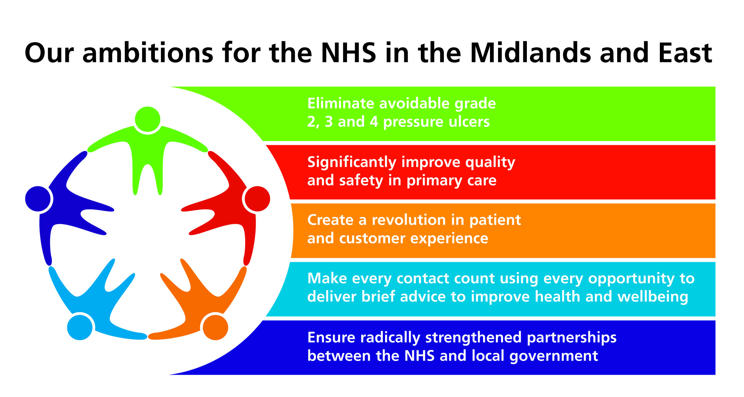
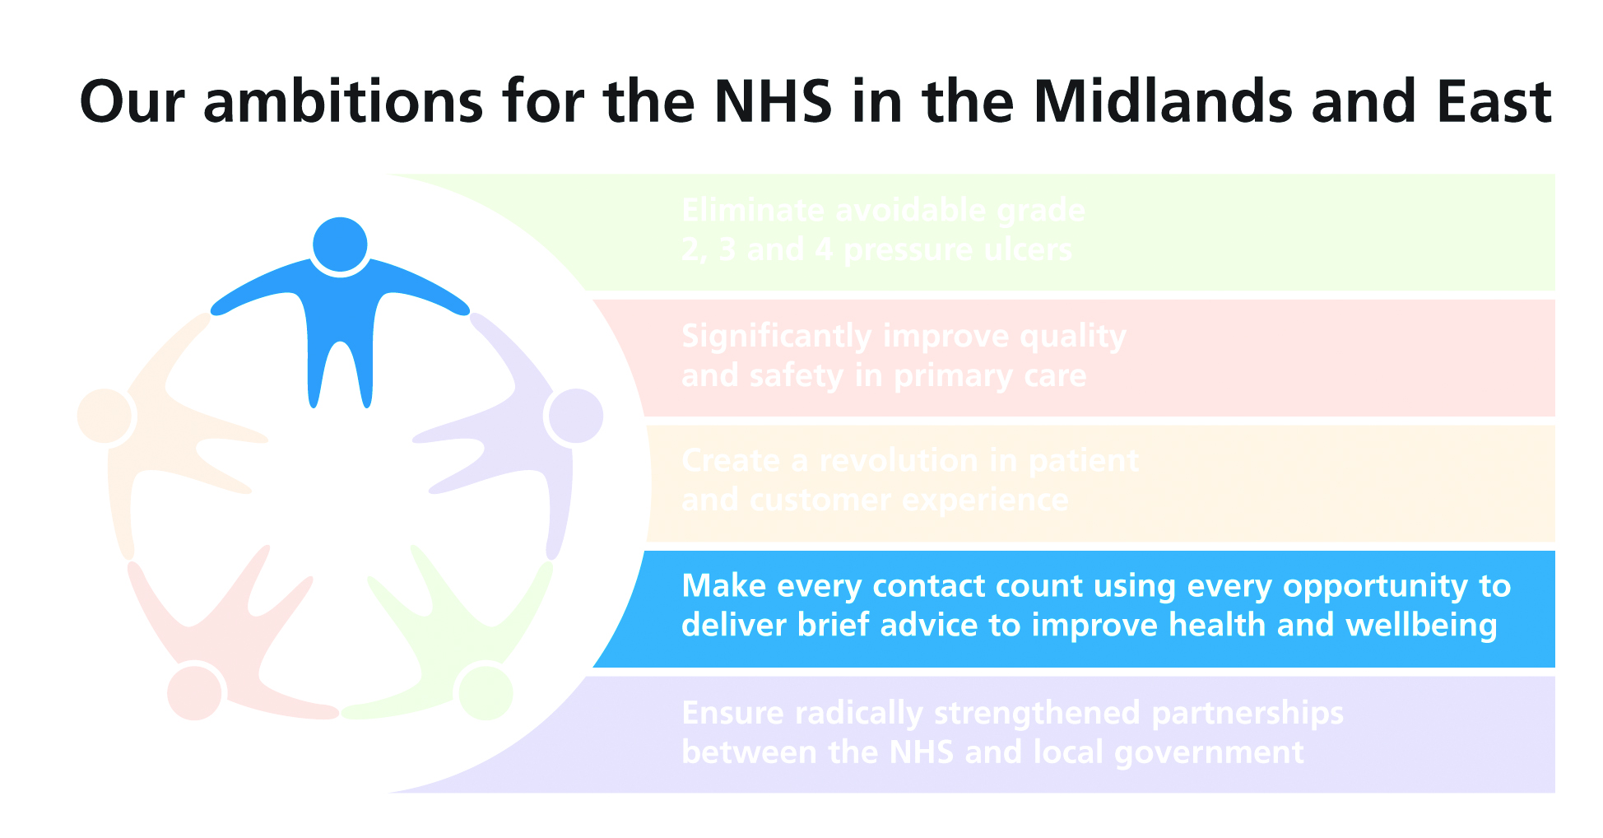

How to use the Board Champion / Implementation Lead communications toolkit

This communications toolkit has a number of elements to help communicate with organisational leaders about MECC.

This Board Champion / Implementation Lead communications toolkit contains:
- An article on the Implementation Guide and Toolkit
- Top 5 MECC messages
- Frequently asked questions
- Power point presentation.
- Case studies of staff trained to deliver MECC
- Poster template
- By-lined article on MECC from Board Champion
- By-lined article on MECC from Implementation Lead

Article on Implementation Guide and Toolkit
On 18 May 2012 the Implementation Guide and Toolkit was launched. This article is for use in board or leader level communications, to brief the executive team and team leaders. It introduces and explains the guide and toolkit to support the launch of MECC in your organisation.

Top 5 MECC messages
These are the most important messages to board / leaders about MECC. They should be used in any communications with board / leaders and could be used in a phased approach.

Frequently Asked Questions
This is a list of common high level questions for reference or use as an appendix to the implementation guide article to form a briefing pack for organisational leaders.

Power point presentation
The presentation provides an overview of the MECC Implementation Guide and Toolkit, for use in board, executive and departmental team meetings. This should be made available to MECC organisational leaders for them to use with their teams.

Case Studies (one included more to follow)
The case studies from staff relate their real experiences of making every contact count following training that is outlined in the Implementation Guide and Toolkit. They should be used in staff-facing communications such as newsletters or your intranet and board facing communications to illustrate the practicalities of implementing MECC and to share learning and best practice. This is to illustrate that MECC is not something staff should be worried about delivering.

Poster template
The template is designed to be customised to suit individual organisations and used to support the launch and implementation of MECC in your organisation. Posters can be adapted as required and displayed in staff areas to support your MECC launch.

By-lined article on MECC from board champion
The article is written to support MECC implementation. It is designed for use in staff facing communications such as newsletters or your intranet alongside a picture of the person by-lined. It is written as spoken by your nominated board champion to staff and explains MECC and why it is a priority. It is used to illustrate your board level commitment to MECC and convey leadership endorsement to staff. Please feel free to adapt this following consultation with your board champion.

By-lined article on MECC from organisational lead
Similar to the above this could be used as a follow-up article on the intranet or in the next edition of staff newsletters. It can be used to illustrate the commitment and expectation of organisational leaders in relation to MECC. Please feel free to adapt this following consultation with your board champion.
Article on Implementation Guide and Toolkit

TITLE: Making Every Contact Count –Implementation Guide and Toolkit

Health and wellbeing promotion is at the very core of NHS culture. All organisations have opportunities to improve people’s mental and physical health and wellbeing to help them stay well and improve their quality of life. As an NHS organisation we have a responsibility to protect and improve the overall health and wellbeing of our staff and service users. This is one of the reasons why we are adopting MECC and have identified [name of your Implementation Lead] as the Implementation Lead for our organisation to support our staff to use MECC.

MECC is defined as “Make every contact count to deliver brief advice to improve health and wellbeing” and is about staff taking the opportunity of their contact with patients and the public to deliver healthy lifestyle information on smoking, healthy eating, maintaining a healthy weight, exercise and alcohol intake regardless of the nature of the patient’s appointment. Within the NHS across the East Midlands, East of England and West Midlands there are 288,000 staff who have millions of contacts with service users each year, presenting a tremendous opportunity to improve individual’s health. Many PCTs have included MECC in their CQUINs for 2012/13, with specific metrics for measuring adoption and success which include whether organisations have board level champions and implementation leads. The NHS Future Forum also made the recommendation that every healthcare professional should make every contact count – use every contact with the public to help them improve their health.

There are clear benefits to organisations which adopt MECC. These include improvements in service quality, improvements in service user and staff health and wellbeing, reducing inappropriate use of services, reduced staff absence, increased productivity and cost savings.

The MECC Implementation Guide and Toolkit has been developed, using evidence of what works best in achieving sustainable change and improvement, to assist Implementation Leads with MECC delivery. It offers a step-by-step process for systemic implementation and a number of practical tools, resources and examples of good practice. A holistic approach has been used using three core components:
- Organisational readiness
- Staff readiness
- Enabling and empowering the public

Our Implementation Lead will be using the toolkit to help with the delivery of MECC. The Implementation Guide and Toolkit design allows users to go directly to the relevant sections with the implementation section. It is also flexible enough to enable users to choose the parts of the process that best fit the needs of their organisation.

A number of delivery tools identified as exemplar as well as examples of practice from differing organisations are also available.

The MECC Implementation Guide and Toolkit is available at this link: http://nhs.lc/makingeverycontactcount . Contact your implementation lead, [name of your Implementation Lead] for more information about Making Every Contact Count.

ENDS
Top 5 MECC Messages for organisational leaders

Making Every Contact Count (MECC) Implementation Guide and Toolkit top messages

- MECC asks staff to take the opportunity to talk to people about healthy lifestyle choices - stopping smoking, drinking alcohol within recommended limits, having a healthy diet, maintaining a healthy weight and undertaking the recommended levels of physical activity. Resources are available to help staff confidence with this.

- As an NHS organisation we have a responsibility to protect and improve the overall health and wellbeing of our staff and service users. Through our Implementation Lead, the Implementation Guide and Toolkit will help us to support our organisation and staff to achieve this – and promote an organisational culture of health and wellbeing.

- The Implementation Guide and Toolkit is designed to prepare and facilitate organisations’ implementation of MECC with tools, resources and prompts on how to tailor them. It enables organisations to review current practice and identify areas where they can get even better at improving the health and wellbeing of staff, service users and the public.

- The Implementation Guide and Toolkit is designed to encourage a positive culture change towards prevention, helping to bring the promotion of mental and physical health and wellbeing into everyday practices, procedures and policies. This will lead to higher quality services, for less cost to the organisation and the service user.

- The Implementation Guide and Toolkit can also promote and improve the health of the workforce. Although it is service user focused, the training offers the opportunity to increase staff knowledge and skills of health and wellbeing and may prompt staff into making a positive change to their own health and wellbeing.
Frequently Asked Questions

Implementation Leads Q&A

Why do I need the Implementation Guide and Toolkit?
All organisations responsible for the health, wellbeing, care and safety of the public have the opportunity to improve a person’s mental and physical health and wellbeing, to help them stay well and improve their quality of life. This Implementation Guide and Toolkit will assist MECC Implementation Leads in achieving this – to make every contact with your service users’ count.

The Toolkit is designed to encourage a positive culture change within organisations towards prevention and taking a holistic approach to a person’s health. Engaging organisations and staff in this new approach will help to bring the promotion of mental and physical health and wellbeing into your everyday practices, procedures and policies. In doing so, you will be helping to provide a higher quality service, for less cost to the organisation and the service user.

My organisation is already a health improvement organisation so why do I need the Implementation Guide and Toolkit?
The Implementation Guide and Toolkit will enable your organisation to review its current practice and identify areas where it can get even better at improving the health and wellbeing of its service users. It will also enable organisations or services that specialise in certain aspects of health, to discuss a person’s other health and wellbeing needs. For example, a physical activity officer will have the opportunity to talk to their service user about other aspects of their health and wellbeing (such as stress or diet) and should take these opportunities when appropriate.

How can I tailor the Implementation Guide and Toolkit to meet the needs of my organisation?
The Implementation Guide and Toolkit is designed for use by MECC Implementation Leads to prepare and facilitate organisations’ implementation of MECC with tools, resources and prompts on how to tailor them. Ideally all staff should be involved in the implementation of Making Every Contact Count because all staff have an opportunity to influence others, whether it is by talking to service users, discussing with colleagues or changing processes or application forms.

How will I know the Implementation Guide and Toolkit has had an impact?
The implementation process within the Implementation Guide and Toolkit facilitates thinking about the outcomes that are essential to your organisation and provides examples of what success might look like. Although ‘success’ in relation to outcomes from contacts with service users will not always be a referral to a service (nor will it just be handing over a leaflet), in some instances, no further action will be required. What is important is initiating and conducting an appropriate dialogue. There are resources within the Toolkit that can be used to give ideas about how the impact might be monitored.

Why does the Implementation Guide and Toolkit take a team approach to implementation?
A local, team-based approach to implementing the Implementation Guide and Toolkit is crucial to truly make contacts count. In each organisation, the service users, staff, teams, strengths and challenges are different. Therefore, successful implementation should be driven by each organisation’s local context, culture and processes. Decisions will need to be made about the most appropriate way of getting the most from the Implementation Guide and Toolkit by each organisation’s leadership and staff, in particular your Implementation Lead. This may mean that adaptations to the organisational culture and process will need to be made. It is therefore crucial that the Implementation Guide and Toolkit is flexible, adaptable and that local teams feel able and willing to take ownership.

How will the Implementation Guide and Toolkit promote and improve the health of my workforce?
Although MECC is service user focused, the training offers the opportunity to increase staff knowledge and skills of health and wellbeing, which they themselves might find useful. Organisational systems and processes designed to encourage healthy living and promote its benefits will be visible to staff and organisations can consider how they further strengthen their communication and support mechanisms to staff who may want to make a positive change to their own health and wellbeing.

Does my organisation have to implement all three components of the Implementation Guide and Toolkit?
Getting the organisation and staff ready for implementation is vital to achieve the third component of The Three Core Components To Implementation (Enabling and Empowering the Public), but the way in which these are implemented and to what degree should be driven by your local context. Your organisation may already be well along the route to Making Every Contact Count and therefore require only minimal interventions, or there may be significant changes to your culture and practices required. Implementing all three components will help determine this. Also, there are a number of tools and resources provided throughout the Implementation Guide and Toolkit which may be useful, or your organisation may already have systems and materials in place which simply need updating to reflect the new philosophy. Fundamentally, the Implementation Guide and Toolkit is flexible and adaptable to enable individual organisations to take ownership of it.

Leadership/board level Q&As

Why is this important to my organisation?
Successful delivery of MECC is of immense value to your organisation. As well as helping to drive higher quality services, for less cost to the organisation, you will be contributing to the improved health and wellbeing of your staff and improving public health. Many PCTs have included MECC in their CQUINs with specific metrics for measuring adoption and success. The NHS Future Forum also recommended that every healthcare professional should make every contact count – use every contact with the public to help them improve their health.

Isn’t this just a distraction from more important priorities that are facing us?
MECC will help in delivering priorities around driving up quality and reducing costs. Your organisation will benefit from a healthier workforce and managed demand for your services in the longer term.

Will it be a lot of extra work for my organisation and staff?
The MECC Implementation Guide and Toolkit has been designed for use by your MECC Implementation Lead to build upon existing initiatives and service delivery and should therefore not be seen as an additional burden for your staff. Implementing the three components of the Toolkit enables an effective and smooth delivery of health improvement for your organisation. Whilst a lead for implementation will need to be identified at start-up, once implemented and embedded as a way of working within your organisation MECC should be easily sustainable and part of everyday practice.

Will non clinical members of staff be expected to give information?
MECC is intended as a vehicle for frontline staff to provide systematic healthy lifestyle information to the people they come into contact with. Those in non-clinical leadership roles should help to ensure that this can happen within their organisation. By taking a team approach to the service delivery, you can use additional skills and experience of all team members to successfully deliver MECC.

What does this mean for specialist roles then?
There has been some concern about MECC diluting specialist single issue focused work. This is not the case, and there will always be a necessity for the specialist areas. The role of MECC is to explore and promote health and wellbeing generally, and this is why it is important to build on existing practices using the team approach.

Power point presentation
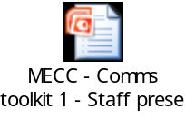To open the document as an editable presentation in PowerPoint, right click the icon, click on ‘Presentation Object’ and then click on ‘Edit’.
Case Study

My experiences of using MECC - Andrew Bushnell, Physiotherapy Assistant St Andrew’s Healthcare

“I began working as a Physiotherapy Assistant on a TBI rehabilitation unit at St Andrew’s Healthcare when the Trust was preparing for the MECC pilot project. Due to my previous experience I soon became involved with the project in a leadership capacity.

“I had worked in a number of health and social care environments before St Andrew’s and was very aware how interpersonal communication is critical to health promotion/improvement work. Good communication skills are vital to support clients to make positive health-behaviour changes to their lifestyles. I often encountered people who were reluctant and resistant to making the lifestyle changes that I could see might benefit them. I tried creative ways to motivate and inspire them, unfortunately often without success.

“Considering the nature of the interactions I had with clients, deciding how I might improve my approach proved difficult. It wasn’t until after I had completed the MECC training that I realised MECC’s potential. If a team worked together using MECC they could make the most impact on a client’s attitudes and health behaviours and ultimately improve their quality of life.

“Although I did consider the MECC training a bit too generic for our specific client group it introduced a variety of behaviour change principles that helped underpin the health improvement work I was already doing. This allowed me to adapt the principles to suit my situation. 98% of our team attended the MECC training (over 25 people) and their feedback was very positive. For me personally I got on well using the MECC skills because they enhanced a practice I was already involved with. I found the conversations I had with clients after MECC training to be more positive, better structured and better managed than before. I felt more confident and better able to do my job. And it didn’t stop there. I continued my learning and began to look for further ways to support people with their weight management, healthy eating and lifestyle changes and found a number of additional resources on behaviour change principles. It was very easy to enhance my MECC skills through this additional learning, with MECC a necessary building block for my development.

“Due to a relatively high rate of staff turnover, there is a risk that our team’s MECC practice could lose momentum so we are planning refresher MECC training sessions as we are convinced of the value of using MECC skills.

“Being a part of the MECC project has been inspiring and I consider it was a ‘missing link’ in my learning. It has affected me professionally and personally, resulting in a more positive approach to my own health behaviour. It has made me more self aware and conscious of how I communicate with clients, friends and my family. I realise that everybody can benefit from subtle support with their health and consider MECC to be one of the most critical learning and development needs for health care professionals. To those new to MECC, I’d say this; persevere - even if it feels somewhat alien to begin with, it adds structure to your interaction and communication with clients and helps you to support health improvement more efficiently. If your colleagues use MECC too then you will soon begin to realise how effective it is at tracking and monitoring health improvement within the work place. I hope to continue to develop my expertise within this field and recommend that other health professionals do the same.

“Good luck and make every contact count!“

Matthew Bushell, Physiotherapy Assistant.

ENDS

Poster

To open the document as an editable word document double click on the icon.

By-lined article on MECC from Board Champion

[name], [organisation title]’s MECC Board Champion talks about the Making Every Contact Count and what it means for [your organisation].

“I am both pleased and excited that [name of organisation] has become part of the Making Every Contact Count (MECC) ambition for NHS organisations in the Midlands and East of England. I will be championing that ambition across the Trust along with [name, title] our Implementation Lead.

“As an NHS organisation we have a responsibility to protect and improve the overall health and wellbeing of our service users / patients and staff, which is why we would like you all to help make every contact count and we will support you to do that.

“We know from large scale research studies that people who follow the four healthy lifestyle behaviours of:
- not smoking
- drinking alcohol within the recommended daily limits
- taking regular exercise and
- eating a healthy and balanced diet

will live on average 14 years longer. Cancer Research UK published a report in December 2011 that showed that over 100,000 new cases of cancer each year are linked to the lifestyle factors of smoking, alcohol, diet and excess weight.

“Research tells us that simple brief information delivered by NHS staff can help and motivate people to change their behaviour and improve their health and wellbeing. Giving brief information takes just a few minutes and can change someone’s life for the better. It will also help reduce future demand on NHS resources. If everyone working in NHS Midlands and East delivered brief advice 10 times a year nearly three million people would benefit and if one in 20 of those went on and stopped smoking, for instance, then 150,000 would have quit.

“I want MECC to be a big part of our organisation, our staff and our patients. To do this we will support you to change your own lifestyle, if needed, and train you to deliver brief advice and signpost people to services that provide further support. We will also encourage patients to seek information from our staff by promoting MECC and its benefits to them.

“Together we can Make Every Contact Count, look out for activities to help you to change your lifestyle for the better and provide training opportunities so you can deliver brief advice to help others.”

ENDS
By-lined article on MECC from Implementation Lead

[name], [organisation title]’s MECC Implementation Lead talks about the Making Every Contact Count and what it means for [your organisation].

“I’m thrilled to be the Implementation Lead for the MECC ambition. It’s something we can all deliver so I look forward to working with everyone.

“MECC builds on our own programme [add more detail here]. We treat people every day for illness and conditions and now we just need to think wider about how we can help people with their lifestyle choices which may affect the success of the treatment we give them.

“We asked service users / patients whether they would welcome this help and found that many would really appreciate the opportunity to talk to staff about lifestyle issues. We also know that service users / patients may not want to start this conversation themselves, or may assume that staff are too busy to talk, so we, as NHS staff, shouldn’t be too worried about opening a MECC conversation.

“Research amongst Midlands and East of England staff showed that they often believe that they need to be experts in smoking cessation services or know-alls on exercise classes to be able to deliver MECC. That isn’t the case, this is about everyone taking advantage of opportunities should they present themselves. For instance, if a patient or colleague mentions about stopping smoking or weight they’ve gained, we should be helping that person by encouraging them to take action. This is called a brief intervention and that is all we’re asking people to do.

“We know a number of staff would feel more confident delivering MECC once they’ve had training so we are looking at a number of training tools that were recently launched. The Implementation Guide and Toolkit, which has examples of best practice, is something we’ll be looking to adopt and adapt for use in [name of organisation].

“I really hope all staff embrace MECC for the simple notion that it is and not be put off by thinking it requires expertise or specialist knowledge. By implementing the MECC ambition we are building on the work we have already done [insert examples].

“Everyone who works in the NHS can become part of MECC and I hope you take up the challenge.”

To see the Implementation Guide and Toolkit http://nhs.lc/makingeverycontactcount

ENDS

