Making Every Contact Count (MECC)

Communications Toolkit 3 – “Walking the Talk” - encourages staff to make their own healthy behaviour changes

This is a communications toolkit aimed at communications leads. It is one in a series of MECC communications toolkits that have been designed and written to give you everything you need to explain more about MECC within your organisation.

The contents of this toolkit have been developed by communications and public health experts to communicate to staff the importance of making their own healthy behaviour changes. Please feel free to adopt and adapt to suit your organisation and its culture.

Your organisation has been asked to nominate an Implementation Lead who will oversee the embedding of MECC within your organisation. Please work closely with them using the materials provided.

The ambition also has a number of graphic devices (see below) which can be used to brand MECC materials.
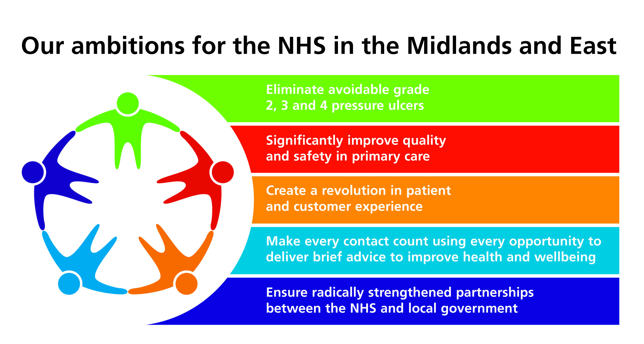
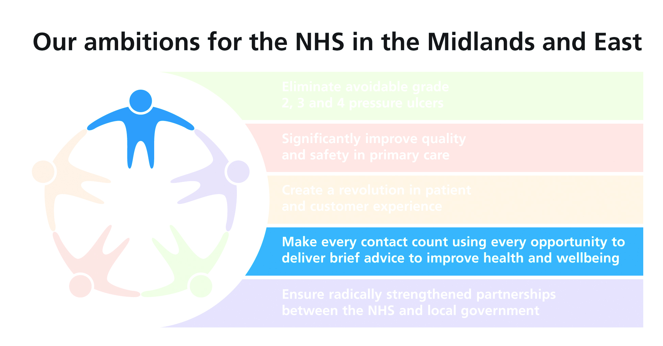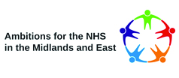

How to use toolkit 3

This communications toolkit has a number of elements to help explain the importance of staff behaviour when influencing patients. Insight work has shown:
- Staff think that their lifestyle and appearance doesn’t affect the impact of the advice they’re giving – they’re professionals. However our research has shown this not to be true. Staff appearance and lifestyle is important to public and patients. Staff need to appreciate that their own lifestyles do have an impact on patients and service users and it is important that they “Walk the talk” when it comes to MECC.
- Public and patients respect professional support and advice and expect to have conversations with staff on relevant lifestyle issues
- Public and patients are more accepting of healthy lifestyle messages if they perceive that staff are following their own advice i.e. Walking the Talk
- Public and patients value the opinions of staff that have changed their own behaviour – eg lost weight, stopped smoking etc.

This toolkit contains:
- Articles for staff-facing communications on:
  - Stopping smoking
  - Healthy eating and getting your 5-a-day
  - Getting the recommended amount of physical activity
  - Drinking alcohol only within the recommended guidelines
- Case studies from NHS staff who have changed their behaviour:
  - Stop smoking case study
  - Healthy eating case study.
  - Healthy eating/physical activity case study
  - Alcohol case study
- Quizzes to test staff on their behaviour

Articles for staff
These can be used in your internal staff communications, such as newsletters or your intranet.

Case studies
These are stories from NHS staff about how improving their own lifestyles have made a big difference to them. They can be used in staff facing internal communications to support the general staff articles; or you may wish to use your own staff case studies.

Quizzes
Each quiz can be used as a presentation in team meetings or in your staff communications. They test staff on their behaviour – how healthy are they? The aim is to nudge staff into making changes.

Other ideas
Before starting this element of the communications strategy you may wish to poll your own staff to find out how many of them go against government guidelines with their own behaviour and / or how many of them intend changing their behaviour. Alternatively, if you’re taking a social marketing approach, you may wish to segment your staff.

DH developed a population segmentation tool for public health professionals called Healthy Foundations. It is a series of 30+ questions designed to determine which of five segments the population fall into:

- Health Conscious Realists
- Balanced Compensators
- Live for Todays
- Hedonistic Immortals
- Unconfident Fatalists

From this PH professionals can develop interventions that will be influence the segments. However, research showed the tool had too many questions so it was streamlined by DH to just eight. These give 70 per cent accuracy.

In 2010 NHS East Midlands surveyed staff in NHS organisations in the region. The survey included the eight questions. The 500 returns allowed us to work out that 37 per cent of our NHS staff fall into the Hedonistic Immortals segment compared to only 19 per cent of the general population.
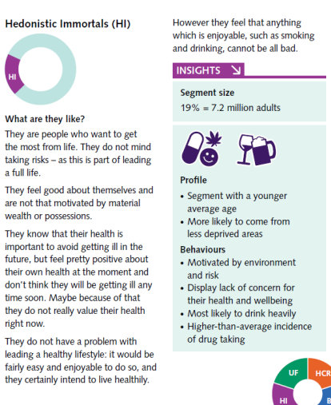

This insight has been used in developing this comms toolkit.
Articles

Article on MECC Stopping Smoking

TITLE: A breath of fresh air

Do you look forward to it and the chance it provides to relax? Or does it dictate where you go and what you do? If you spend your time panicking about when you can have the next one, or cramming as many in as you can in your break, then maybe it’s time to think about binning those cigarettes.

We all know the health risks involved, but we all work hard so a little of what you fancy does you good. Right? Wrong. Smoking kills half of all long-term users and is the main single cause of avoidable premature death in the U.K. There’s also the effect of smoking on others. For instance, in England around 50 children are admitted to hospital each day with conditions, such as asthma attacks and middle ear infections, because of exposure to second-hand smoke.

If you sometimes find it frustrating when you suspect your patients / service users lifestyles are not helping their overall health, picture yourself as the patient, suffering with a chest condition. What would you say to yourself about smoking?

As NHS staff we are all very focused on the health of others, but no matter how busy we are, (or invincible we think we may be!) we deserve to give some priority to our own health and future. And we know that patients / service users take their cues from us so if we’ve been through the experience too they’re more likely to listen and act on our advice. If you’ve stopped smoking, or know someone who has, this really helps, as we know that patients enjoy listening to others’ experiences.

Box out
- Stopping smoking is possible – there are over 11 million ex-smokers in the UK to prove it.
- You are four times more likely to quit with an NHS Stop Smoking Service than by going it alone.
- There are a range of products available to help you to quit including nicotine replacement products (patches, gum etc.).
- It’s not too late to think about stopping and it will be of benefit whatever your age.
- Stopping smoking in pregnancy will protect your baby from harmful effects of smoking and stopping for good will protect children in the long term.

Plus there are all the other benefits, such as having more money, being able to taste your food, regaining your sense of smell (and smelling better to others!) and so on….

Box out
When you stop smoking the benefits soon kick in:
- Within 20 minutes your blood pressure and pulse should return to normal and your circulation improve, especially to hands and feet.
- Eight hours later your blood oxygen levels will return to normal and your chances of having a heart attack start to fall.
- Five years later your risk of having a heart attack will be half of that of a smoker.
- Ten years later your risk of lung cancer falls to about half of that of a smoker and your risk of a heart attack is about the same as someone who has never smoked.

If you’re ready to quit we’ll help support you. Contact name / contact details.

ENDS
Case study

TITLE: How I Quit Smoking

By Vicki Harvey

“I’m the PA to the Director of Business and Commercial Development at South Staffordshire and Shropshire Healthcare NHS Foundation Trust.

“I’m 40, married with a young family and had been smoking for 27 years (since I was 13!).Over the years I had made a few attempts to stop, particularly when I was pregnant with each of my two sons. I managed to stop for a while, but I never quite managed to succeed completely. Once my sons were born, I relapsed into old habits.

“At the end of last year I decided it really was time to stop for good. I have a family history of heart disease and knew my smoking increased my risk. Plus my sons were upset with me for continuing to smoke and I really couldn’t justify the amount of money (and time) that I was wasting on cigarettes. I was also acutely aware of how anti-social being a smoker is.

“I heard about a smoking cessation group that was going to be run at work and the more I found out about it, the better it sounded. It was just before Christmas 2011 when I heard about the group, with the first meeting scheduled for 10 January 2012. I went along to the first meeting and set my quit date for the following week, 17 January and I have not had a cigarette since.

“A combination of NRT (patches and inhaler) and the help of the smoking cessation facilitator helped me to quit. Another gadget that helped was the NHS iPhone app that calculated how much money I was saving. When the cravings came, I would look at how much I have saved and that was enough to bring on an extra burst of willpower!

“Since giving up smoking I honestly feel great. I now go to Boxercise classes every week and also do the two mile walk from work to home at least three times a week, all without becoming too out of breath and without a tight chest. In 2010, whilst still a smoker, I took part in the Race for Life, wheezing all the way round. I have registered for it again this year and think it will be much more enjoyable this time around!

“Of course there are times when the craving still comes, but I just think how far I’ve come and what would be the point of starting again now when the hard part is done.

“The best thing about giving up though is how proud of myself I feel and how proud of me my children are.

“The best advice I could give to anyone thinking about giving up smoking is to contact their GP or local smoking cessation group, as I found that the extra support of being part of a group really helped me.

“I still have one challenge ahead, which is to convince my husband to quit. I’m working on it – if I can stop anyone can!”

ENDS

Vicki Harvey, PA to the Director of Business and Commercial Development, South Staffordshire and Shropshire Healthcare NHS Foundation Trust
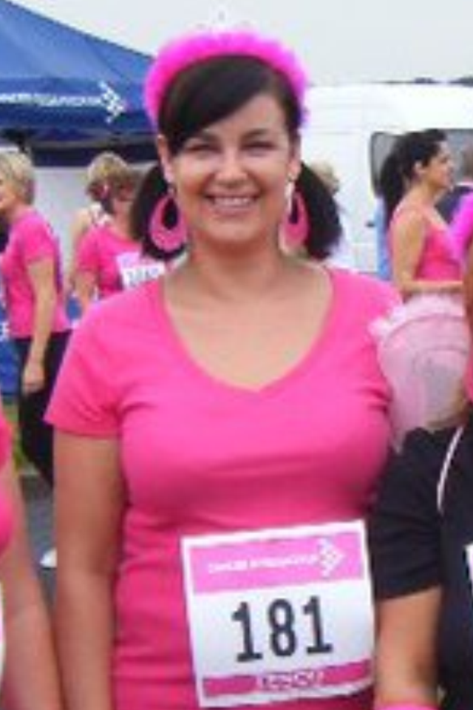
Vicki Harvey at Race for Life 2010

Quiz

Are you ready to quit?
Take our quick quiz to find out what sort of quitter you are and what support will help when you decide to quit.

1. How long have you smoked for?
a) The last 5 years
b) Between 5 and 15 years
c) Between 15 and 25 years
d) Over 25 years

2. When do you smoke most?
a) When I’m with friends
b) When I’m stressed
c) IF I’m having a break from the kids
d) All day, every day!

3. Who else do you know that smokes?
a) Friends, although some are cutting down
b) Friends
c) Other family members
d) Nearly everyone I know

4. Have you tried to give up before?
a) No, I don’t want to give up
b) Once or twice, but it was really hard
c) Loads of times, but always started again
d) Yes, but not for a while

5. Are you worried about your health?
a) I’m healthy, so I’m not worried
b) I’m worried
c) I’m not worried; I live my life ONE day at a time
d) I’m a bit concerned because I want to see the young ones grow up

6. What worries you most about giving up?
a) It would put a downer on my social life
b) Coping with the stress
c) Putting on weight
d) It’s too difficult and I don’t want to fail again

Mostly As
The Young Invincible - You want to quit smoking… but you’re young enough to worry about it later. You’re fit and healthy – smoking doesn’t seem to be touching you, so you’re not in any rush. Plus it would put a downer on your busy social life. You’ve tried to quit before, but can’t resist the temptation when friends offer you a ciggie or after having a few drinks.

Ready to quit? You’re fit and healthy, what’s the rush? Chat to an expert about the risks of smoking without the hassle of making an appointment.

Pharmacy: The staff in your local chemist have an expert understanding of smoking and quitting from a factual, medical perspective. They offer a wide range of Stop Smoking Products and are ideally placed to recommend the one that is right for you. They’re also available at any point during the day, without an appointment – often when other services are unavailable. If you’re the sort of quitter that struggles with cravings, informal, one-to-one counselling combined with an expert knowledge of Stop Smoking Products makes your pharmacist the ideal ally in your battle to quit smoking.

Mostly Bs
The Boiling Pot - You want to quit smoking, but worry how you’ll cope with the stress. Juggling a busy, hectic life, you rely on the ciggies to help you keep a lid on things. Plus you’re worried you might end up putting on weight!

Ready to quit? You’re worried you’ll pile on the pounds if you leave off the cigs. Combine quit smoking tips with healthy eating advice.

GP: Your local GP is perfectly placed to give you the best possible start on your quitting journey. Because they understand the science behind smoking and quitting, they can clearly explain the risks associated with smoking and describe the changes your body will go through when you start to quit. As a community-based medical expert they have the full range of stop smoking services at their disposal and have the knowledge to help you choose the ones that are right for you. Most importantly, because your GP and his team already know you, they understand the sort of quitter you are and are able to offer help that will give you the best possible chance of quitting.

Mostly Cs
The Weight Watcher - You want to quit smoking, but worry you’ll end up piling on the weight. The extra money would come in handy, but you think the pounds you save on the cigs will just end up on your waistline.

Ready to quit? You’re worried you’ll pile on the pounds if you leave off the cigs. Combine quit smoking tips with healthy eating advice.

GP: Your local GP is perfectly placed to give you the best possible start on your quitting journey. Because they understand the science behind smoking and quitting, they can clearly explain the risks associated with smoking and describe the changes your body will go through when you start to quit. As a community-based medical expert they have the full range of stop smoking services at their disposal and have the knowledge to help you choose the ones that are right for you. Most importantly, because your GP and his team already know you, they understand the sort of quitter you are and are able to offer help that will give you the best possible chance of quitting.

OR

The Serial Quitter - You want to quit, but have tried everything in the book and feel like you’re bound to fail if you try again. You often crack because friends and family still smoke or other life pressures get the better of you.

Ready to quit? You feel you’ve tried everything in the book. Get one-to-one support AND discuss your options in detail.

Drop-in Support: Moral support and practical help when you need it! Rather than attending sessions at a fixed time every week, turn up when you need us and see an advisor straight away. Contact: add local information

Group Sessions: Strength in numbers! Share experiences and swap tips with other quitters who know what you’re going through. Led by trained advisors these sessions are friendly, informal gatherings in familiar community settings. Contact: add local information

One-to-One: Quality time with an expert! An excellent opportunity to talk in private about the sort of quitter you are and the strategies you need to fight your own particular battle. Contact: add local information

Telephone helpline: Instant support when the cravings strike! Open from 9.30am through to 8.00pm, we are on hand at any point to give advice, discuss your strategies or just get you through a craving. Contact: add local information

Mostly Ds
The Prisoner - You want to quit smoking, but don’t know how you’ll break free after all these years. You love your ciggies and struggle to see the point of stopping now.

Ready to quit? after all these years, the addiction has you trapped. Stop smoking products take the edge off the cravings so you CAN break free.

Speak to your pharmacist or Stop Smoking Advisor before making a choice. If you get your prescriptions free Stop Smoking Products is available through the NHS without cost. There are a wide range of products available, with different pros and cons. Contact: add local information

Nicotine gum: When you chew nicotine gum, the nicotine is absorbed through the lining of your mouth.

Nicotine patches: Nicotine patches work well for most regular smokers and can be worn around the clock (24 hour patches) or just during the day (16 hour patches).

Microtabs: These are small tablets containing nicotine which dissolve quickly under your tongue.

Lozenges: Sucked slowly to release the nicotine and take about 20-30 minutes to dissolve.

Inhalators: Inhalators look like a plastic cigarette. The inhalator releases nicotine vapour which gets absorbed through your mouth and throat. If you miss the ‘hand to mouth’ aspect of smoking, these may suit you.

Nicotine nasal spray: Delivers a swift and effective dose of nicotine through the lining of your nose.

Non-nicotine tablets: Champix and Zyban are tablets that help reduce cravings and stop you feeling the satisfying effects of a cigarette.

OR

The Creature of Habit - You want to quit smoking, but the cigs go hand-in-hand with the best bits of the day! Brew time, teatime, pub time, me time – the routine feels completely unbreakable.

Ready to quit? Ciggies just go hand-in-hand with the best bits of the day. Get instant support to get you through the crisis cravings.

Moral support: Being at work can be one of the most challenging aspects of the quitting journey. The cigs go hand-in-hand with your brew and lunch breaks and you can feel left out as your mates nip out for a quick puff. Contact: Add in details of local services for work-place support.

Quiz courtesy of NHS Knowsley

If you would like help stopping smoking add in details of local service/s
Article on MECC – Healthy Eating

TITLE: If it tastes good…

We all have busy lives – a hectic work and home life can all put pressure on our time – so choosing convenience seems sensible. And a healthy appetite’s a good thing isn’t it? But do we always make the right choices when it comes to food?

As NHS staff we’ve become good at spotting when patients’ / service users’ health might benefit from a better diet but how about ourselves? We owe it to ourselves to give our own health some priority too. We already get a lot of messages about the importance of a healthy diet and perhaps it all seems a bit of a nag but it really is important stuff!

Making sure that you are eating five portions of fruit and vegetables a day makes a big difference to your health. Eating healthily is also about eating the right amount of food for your energy needs. The NHS “eat-well” plate recommends basing meals on around a third starchy foods (bread, rice, potatoes). Eating more fish, reducing fat, sugar and salt and drinking more water is the way to a healthy diet and, combined with enough physical activity, maintaining a healthy weight.

Eating more fruit and vegetables doesn’t have to be expensive; tinned, frozen and dried are just as good and it’s also cheaper to eat foods that are in season. Most of our salt intake comes from processed foods – so try to reduce these. You can reduce fat in your diet in a number of ways. By cutting off visible fat from meat, spreading fats more thinly and cutting down on fatty and sugary snacks.

Cutting out the junk food and making sure your diet is balanced means you will be avoiding unnecessary health risks and you will feel better too. If you’ve made positive changes to your diet and felt the benefits don’t be afraid of sharing with them patients, they’ve told us they appreciate advice from people that have made changes.

For more information about healthy eating see www.eatwell.gov.uk or NHS choices

Box out
For instance, did you know?
- One in three deaths from cancer and one in three deaths from coronary heart disease are attributable to a poor diet
- Reducing salt intake to the recommended 6gms a day for adults would contribute to a 17 per cent reduction in high blood pressure in the UK population
- In England only 26 per cent of people claim to eat 5-a-day – i.e. five portions of fruit and vegetables.

For specific diet related information at (Your organisation) see: xxxxxx

ENDS
Case Study

TITLE: How Getting My 5-a-day and More Exercise Made a Big Difference!

By Kerry Owen

“I’m an ambulance controller working for West Midlands Ambulance Service at their Emergency Operations Centre at Brierley Hill.

“I’m 27 and for pretty much most of my life I had been overweight, latterly I’d put on more weight which I can see was down to eating too much of the wrong foods on my shifts! Whilst not being particularly happy about this, what really spurred me into action to do something was seeing the evidence of how my weight was affecting my health. When the doctor told me I had high blood pressure, I realised that I needed to make some changes to my eating habits and get more exercise.

“I cut out takeaways and made sure I included more fresh fruit and vegetables in my meals, getting my ‘5 a day’. I started cooking for myself more so I could really see what I was eating. Working shifts I had got into the habit of getting ready meals quite often without taking a lot of notice of how healthy they were – now I’m finding I quite enjoy cooking and it doesn’t take me much more time. I am now generally thinking more about my diet and health, eating smaller and healthier portions and drinking more water. I’ve also joined a gym and go around three times a week which I really enjoy.

A year of eating better and exercising more has made a big difference to me, having lost nearly six stone and dropped six dress sizes and my blood pressure is now normal. My success story was even featured in my local paper.

“Although I’m generally eating more healthily I’m no saint! I still eat out and enjoy chocolate and the occasional tipple but this doesn’t matter when your main diet is so good and you are getting enough exercise.

“Even if you’re not overweight a good diet and regular exercise will boost your health. The best thing about the new me is how fantastic I feel. I have more energy and I'm much fitter than I've ever been.

“Looking back the best advice I would give to anyone is to eat more fruit and vegetables instead of sugary snacks without denying yourself the odd treat. Think about the food you’re choosing - check those labels and move more! I also found setting myself small goals worked really well on the route to a healthier me – you should try it!”

ENDS

Kerry Owen, Ambulance Controller, West Midlands Ambulance Service NHS Trust


Quiz

Think you know your onions? Take this simple quiz, you may be surprised. Is it true or is it false?

1. Fruit juice and baked beans count as one portion of your fruit and vegetable intake.

2. If I eat lots of fruit I don’t need to eat any vegetables.

3. Your fruit and vegetable intake must come from fresh fruit and vegetables only.

4. Wholegrain bread, beans and lentils are a rich source of fibre.

5. A diet containing an adequate supply of fibre will help prevent constipation, lower blood cholesterol levels and help control blood glucose levels.

6. There is more calcium in a pint of skimmed milk than in a pint of whole milk.

7. Turnips and oranges are a source of calcium.

8. Sunlight is a source of vitamin D.

9. A diet containing an adequate amount of calcium and vitamin D will help prevent against osteoporosis.

10. Red meat is a rich source of iron.

11. Oily fish contains omega 3.

12. Saturated fat is better for you than monounsaturated or polyunsaturated fat.

13. Adults should consume a maximum of 6 grams of salt per day.

14. Excess salt could cause high blood pressure and heart disease.

15. It is recommended that we should drink 6-8 pints of water per day.

Box out

Answers

1. True – fruit juice can only count for one of your 5 portions per day ie you can’t have 5 glasses of juice and say you have had your 5 a day.

2. False – you need to eat a wide variety of fruit and vegetables for a healthy diet.

3. False – your fruit and vegetable portions can be made up of dried, frozen or tinned fruit and vegetables.

4. True.

5. True

6. False – skimmed milk contain less fat but the same amount of calcium.

7. False.

8. True.

9. True.

10. True – green leafy vegetables are also a good source of iron.

11. True.

12. False.

13. True.

14. True.

15. True.

Source of quiz Health Education Trust

If you would like help eating healthily add in local service/s
Article on MECC - Activity

TITLE: Are you an armchair critic?

Dashing around at work keeps us active doesn’t it? Apparently not. 70 per cent of us aren’t active enough for it to benefit our health – that is six in 10 men and seven in 10 women. Yet physical activity is really important, it can reduce your risk of major illnesses, such as stroke, diabetes and cancer by up to 50 per cent and lower your risk of early death by up to 30 per cent. Almost 40 per cent of deaths from coronary heart disease are down to inactivity.

NHS staff are very good at identifying when patients’ and service users’ health might benefit by being a bit more active but are we practicing what we preach? We owe it to ourselves to give our own health some priority too. Being more active has a positive impact on the prevention of illness and quality of life, reducing stress, improving sleep and increasing social activity and self-esteem.

How do you feel about how active you are? Perhaps you are full of good intentions but short on time, but you don’t need to start training for running a marathon to improve your health. Latest guidance says adults should be active for 150 minutes a week. You don’t need to do it all at once, it can be done in smaller more manageable sessions. Moderate activity is that which slightly increases your heart rate and makes you feel warmer, but you still should be able to talk comfortably whilst doing it.

You only need to make small changes. Increase your everyday activity - hand wash the car, do more gardening, park further away from the shops, take the stairs instead of the lift…

In return you’ll get fitter, be more relaxed, see improved sleep and your clothes will fit better. If you do makes changes, tell people, particularly patients. They’ve told us that healthcare staff that have made positive changes inspire them too.

For more information about getting more physical activity and some tips on 10 minute activities see NHS Choices: http://www.nhs.uk/LiveWell/Fitness/Pages/Fitnesshome.aspx

For more information about activities at (Your organisation) see: xxxxxx

ENDS
Case Study

TITLE: How I’m Getting More Exercise

By Jatinder Singh

“I am a Programme Specialist for Productivity Improvement based at the Birmingham Office of NHS Midlands and East, the Strategic Health Authority Cluster.

“I’ve really been inspired to lead a healthier lifestyle through a number of staff health and wellbeing initiatives that have been run at the West Midlands office. I decided to join a gym, when a local gym had a stall in the staff room at one of the health and wellbeing events. I got an NHS discount for joining up, which was another incentive. I only joined for four months to start with as I had never joined or even used a gym in the past. After the first four months, I found I was still going at least once or twice a week so I signed up for a year. As a result I feel healthier and fitter and have lost some weight I’ve also become more aware of what I eat and drink.

“Another initiative that prompted me to do more regular exercise was a health kiosk competition at work. This made me more motivated to get the most from my gym membership. The health kiosk machine in our staff room, measured blood pressure, heart rate, body fat and BMI and there was a bit of light-hearted competition amongst staff to see who could make the most improvement!

“I also had a 1:1 planning session with a fitness coach on how I could improve the use of the gym and the sort of different activities I should try. My aim has always been to get healthier and fitter so that I can increase my energy levels. I don’t believe in dieting but rather in making lasting lifestyle changes. There used to be times during the day when my energy levels dropped and I felt a bit lethargic. Since getting fitter this has stopped and I certainly feel healthier now.

“I still eat what I enjoy and have not any made drastic changes to the way I live my life. I have just taken steps towards living a healthier lifestyle in getting more exercise to increase my fitness.

“Healthy Living is not about ‘faddy diets’ and begrudging yourself of what you enjoy, you just have some things in moderation. It always comes back to the age old method of being aware of what’s healthy and getting enough exercise. It never fails!”

ENDS

Jatinder Singh, Programme Specialist, NHS Midlands and East



Quiz

Does exercise bore you? Is it a struggle to get motivated? You may be choosing the wrong keep fit regime! Try this simple quiz to work out your workout personality.

1. When I think about physical activity, I:
a) Can’t wait to put on my walking shoes
b) Really want to exercise but need a push
c) Dread the idea of moving a muscle, but am happy once I get moving

2. When I am physically active, I enjoy exercising:
a) By myself at my own pace
b) With a team or group
c) With one or two buddies

3. I exercise because:
a) I want to stay in shape, slim down, or improve my health
b) I want to see my friends and catch up on the latest news
c) The weather is nice or I just feel like it

4. When I take part in a physical activity, I usually:
a) Plan the event ahead of time
b) Participate when someone else has set up the activity or attend a class
c) Pull it together quickly and do something active when the mood strikes

5. Others see me as:
a) A leader
b) A team player
c) Someone who goes along with a good idea

6. I enjoy physical activities that are:
a) Set by my own routine
b) Set by a professional, teacher, or group
c) Spontaneous

For every answer, give yourself:
a = 1 point
b = 2 points
c = 3 points

If you scored:
6-9 points: you are a self-motivator
10-14 points: you are a team player
15-18 points: you are spontaneous

Self-Motivator
You like structure and organization. Creating and sticking to your own exercise plan is relatively easy, but you may find yourself losing interest in your usual routine. Try adding a few new activities such as biking, rowing, gardening, or hiking. Or try alternating your favorite workouts such as walking, swimming, and weightlifting on different days of the week.

Team Player
To you, exercise is a way to socialize and stay connected to friends and family. Group activities and classes are a natural selection for you. Sign up for an exercise class; put together a group of friends for walking; or join a team sport or sports league such as bowling, softball, or doubles tennis.

Spontaneous
You love freedom and loathe conforming to rigid rules. Things that get you moving might include a call from friends who need a fourth player for a round of golf, a hike in the woods to enjoy a beautiful autumn day, or a walk to the shops when you are out of milk. These activities are great, but make sure you're doing something active on most days.

Quiz courtesy of the American Institute for Cancer Research:

If you would like help with exercise add in local details
Article on MECC - Alcohol

TITLE: Whose round is it?

It’s all around us - about 90 per cent of the UK population drink alcohol, it’s all about relaxing, kicking-back and having fun. In moderation it’s not a problem - but what if it’s going a bit beyond that? 17.9 per cent of the population now drink alcohol at increasing risk and 6.1 per cent drink at what are known to be high risk levels.

Units are a simple way of expressing the quantity of pure alcohol in a drink. One unit equals 10ml or 8g of pure alcohol, which is around the amount of alcohol the average adult can process in an hour. The number of units in a drink is based on the size of the drink as well as its alcohol strength. For example, a pint of strong lager contains 3 units of alcohol, whereas the same volume of standard lager has just over 2 units. A large glass of 12% ABV wine would contain 3 units.

Increasing-risk drinking is regularly drinking more than 3 to 4 units if you are a man or regularly drinking more than 2 to 3 units a day if you’re a woman. If you're drinking at around these levels, your risk of developing a serious illness is higher than non-drinkers.

Higher-risk drinkers are men who regularly drink more than 8 units a day (or 50 units a week) or women regularly drinking more than 6 units a day (or 35 units a week). If you’re in this group, you have an even higher risk of damaging your health. The NHS definition of binge drinking is drinking heavily in a short space of time to get drunk or feel the effects of alcohol. The NHS also defines it as drinking more than double the daily unit guidelines for alcohol in one session

We may see patients, service users or friends and family where it’s pretty clear that their drinking behaviour is detrimental to their wellbeing. How do you see yourself? As NHS staff we are concerned with the health of others, but no matter how busy we are, (or invincible we think we may be!), we owe it to ourselves to give some priority to our own health and future.

How do you feel about the amount you drink at the moment? If you drink more than the recommended limits then you are putting your health at risk. If you ever binge drink then you are at high risk too. Maybe you feel that you can cope with the odd hangover or feeling tired, but have you thought about the possible long-term damage to your health? It doesn't make a difference if you're drinking every day or once a fortnight, exceeding the recommended guidelines is risky, alcohol affects the whole body and can play a role in numerous medical conditions. You have a much higher risk of developing alcohol-related health problems. Your body has probably suffered some damage already, even if you’re not yet aware of it

BOX OUT
What you are risking…
The short term health risks of alcohol include:

- Anxiety
- Sexual difficulties such as impotence and also sexual risk taking /unsafe sex
- Impaired judgement leading to accidents and injuries
- Slowed breathing and heartbeat
- Loss of consciousness
- Suffocation through choking on your own vomit (aspiration)
- Potentially fatal poisoning
- Domestic and other violence and assaults

In the long term, alcohol can contribute to a variety of problems, including damage to an unborn child, liver disease, osteoporosis (thinning of the bones), pancreatitis, stomach ulcers, infertility, heart disease, raised blood pressure, stroke, dementia and brain damage.

It can also lead to an increased risk of a variety of cancers, particularly mouth, breast cancer and cancer of the gullet. It is also frequently associated with mental health problems, such as depression and anxiety.

BOX OUT
What you can do…

- Know your alcohol units and be aware of the amount you are drinking - check your own daily levels.
- Stay in control of your drinking – try and avoid rounds, top-ups and 2 for 1 offers
- Reduce the number of days in the week that you drink alcohol.
- Plan other activities for the times when you would otherwise drink, such as going swimming instead of the pub after work
- When drinking alternate alcohol with water – to keep your body hydrated.

Think of the benefits of cutting back, you can still have fun and relax; you will be avoiding a load of health risks and losing all those extra calories too! And you’ll be able to tell others how much better you feel now.

For more information about alcohol visit NHS Choices. http://www.nhs.uk/Livewell/alcohol/Pages/Alcoholhome.aspx

See this leaflet for good practical advice on cutting back:
http://www.nhs.uk/Change4Life/supporter-resources/downloads/408723_Your_Drinking_And_You.pdf
If you would like to talk in confidence about your alcohol intake contact: add in local details
Case Study

TITLE: No units! By Anonymous *

“I work for the NHS in the Midlands and East and would also describe myself as a busy young mother!

“I definitely wouldn’t say that I have ever considered myself to be problem drinker; although there was quite a big drinking culture when I was at university and I’d certainly done my fair share of social drinking since, especially when I got together with certain friends... The champagne corks popped at my wedding but I gave up alcohol completely in pregnancy. I didn’t find this too difficult – you just want to do what’s best for the baby and it’s an easy decision to put their health first.

“It’s funny but when the baby arrived I didn’t really think twice about starting to drink alcohol again, the wine was back on the menu even though I hadn’t missed going without it for nine months! I think alcohol is so prevalent and acceptable in our society that it can become a habit without you really noticing. It was a glass of wine with a meal, another glass after a meal and sometimes I felt that I really deserved that glass just after finally getting the baby to bed after a hard day!

“There’s no doubt that having a young family can be stressful, and my job’s not without its stresses too. A few months ago, after reading some articles on alcohol, I began questioning whether drinking was actually improving my enjoyment of life or in fact having the reverse effect.

“For me having a drink often signalled the start of ‘grown-up’ relaxing time of an evening; time to put the toys away, my feet up and switch on the TV. The trouble was that, although I felt tired when I finally went to bed (as alcohol causes lighter sleep) I often didn’t sleep well. I didn’t regularly drink on weeknights but a couple of glasses on a Friday night meant I felt dehydrated and headachy on Saturday mornings – the day when I wanted to have fun with my family.

“So after realising that maybe the downsides outweighed the positives I have given up alcohol. I now relax better, sleep better and, as a result have more energy at the weekend to do all the fun stuff with my son. It’s ironic that I thought wine was helping me to relax, when it’s clear to me now that it was making me more tired. It might seem drastic to give up completely but I can honestly say it’s working for me as I feel so much better.

“Maybe it’s time you had a closer look at how much you drink, and think about cutting down. Those units can creep up on you without you noticing – for me less is definitely more!”

Box out
* The fact that we had to use an anonymous case study for alcohol serves to illustrate that talking honestly and publicly about their drinking habits is still difficult for many people. As a society we still find it difficult to talk about the harm alcohol can do to us as individuals and to our friends and family. Let’s make a start by talking to ourselves honestly about how much alcohol we drink and taking action now if we need to.

ENDS

Quiz

Knowing your Limits…
Test your knowledge on booze by answering the 10 questions below

1. The guideline limits on safe drinking are between three and four units a day for men, and between two and three units for women. But which of the above drinks represents only one unit?
a) A large glass of wine
b) Pint of lager
c) An alcopop
d) A short

2. In any given week of the year, what proportion of the population claim to have been abstaining?
a) 10%
b) 20%
c) 40%

3. But isn’t some drinking supposed to be good for you?
a) Yes, that’s right
b) Its an urban myth
c) Only for certain people

4. Red wine in particular has been linked with several health benefits. All of these except which one?
a) It helps prevent the common cold
b) It helps prevent herpes
c) It helps prevent tennis elbow

5. Women in particular are drinking more than in past years. But women of which of these nations are most likely to be non-drinkers?
a) Ireland
b) England
c) Wales

6. According to Alcohol Concern, "this sort of product is aimed at a market which just really wants to drink to get drunk." What?
a) Newcastle Brown Ale ice cream
b) Deco, a lager-absinthe mix
c) Two-Buck Chuck, a US wine selling for just $1.99 a bottle

7. Once alcohol is in your body, it can end up variously as sweat, boozy breath, or a visit to the loo and what's left is broken down by the liver. But how large a share of the task does the liver take?
a) 10%
b) 50%
c) 90%

8. You have a heavy night mid-week. By midnight, you are slightly more than twice over the drink-drive limit, and you walk home from the pub. Next morning, feeling a bit groggy, you get up at drive to work at 7.30am, and get done for drink-driving. Possible?
a) Yes, possible
b) No, by that time I would be all right

9. About 3.8 million people are thought to be dependent on drink in England and Wales, six times the number hooked on drugs. How does funding for treatment compare?
a) Drugs services get six times as much
b) About the same
c) Alcohol services get twice as much

10. Bridget Jones’s Diary: 1 January: 9st 3lb (but post-Christmas), alcohol units 14 (but effectively covers two days as four hours of party was on New Year's Day), cigarettes 22, calories 5,424! What proportion of women are as careful as Bridget at keeping a record of their drinking?
a) 3%
b) 13%
c) 33%
Source of quiz www.bbc.co.uk

Box out
Answers:
1) d - A 175ml glass of wine is two units. A pint of normal strength lager is two units. A 275ml bottle of alcopop is 1.5 units, and a single measure of spirits is one unit.

2) c – source: Figures Office for National Statistics 2000 General Household Survey.

3) c - Research has shown that those drinking about one unit a day have a lower risk of heart attack, chronic heart trouble and sudden coronary death than heavy drinkers or those not drinking at all. But it only applies to people already at risk of heart disease - eg men over 40 or post-menopausal women and drinking more than one unit does not give extra health benefits.

4) c - Red wine could help prevent colds, Spanish researchers found last year. In 2000, US scientists said that when wine was daubed on infectious herpes sores it could prevent the disease being passed on. They also suggested the ingredient could be put in condoms to prevent genital herpes being passed on.

5) a - Source: Alcohol Concern

6) b - Deco blends a shot of the notoriously potent liquor with Kronenberg lager.
The beer-flavoured ice cream contains less than 1% alcohol.
Two-Buck Chuck - real name Charles Shaw - sells so cheaply because of a glut of wine on the Californian market.

7) c

8) a - According to the Department of Transport, if your blood alcohol level is 200mg/100ml at midnight - the legal limit is 80 - by 7.30 the next day it will still be 90. The penalties for drink-driving are disqualification for a minimum of 12 months, and a possible £5,000 fine and six months in prison.

9) a - The charity Turning Point says alcohol services receive £95m annually compared to £573m committed to drug treatment in 2005/6.

10) b - Source ONS

If you want to check your alcohol intake log onto: http://www.nhs.uk/Change4Life/Pages/understanding-alcohol.aspx

If you would like to talk to someone about your alcohol intake add in local details

