An Implementation Guide and Toolkit for Making Every Contact Count: Using every opportunity to achieve health and wellbeing
Tools and resources

Organisational Assessment Tool

As mentioned throughout this Implementation Guide and Toolkit, the support of the organisation is vital in helping staff reach their potential as effective health promoters. This includes providing a health promoting environment for the workforce and ensuring staff have the relevant skills, knowledge and confidence to carry out this role.

This Implementation Guide and Toolkit has adapted the NHS Sustainability Model to help you assess your current position as a health promoting organisation and to analyse areas that may require change or enhancement to achieve improvements. The NHS Sustainability Model has been developed to help organisations implement and sustain effective improvement initiatives that will help increase the quality of services provided and improve service user experience at lower cost. It sets out the three key areas which need to be assessed: process, staff and organisation:
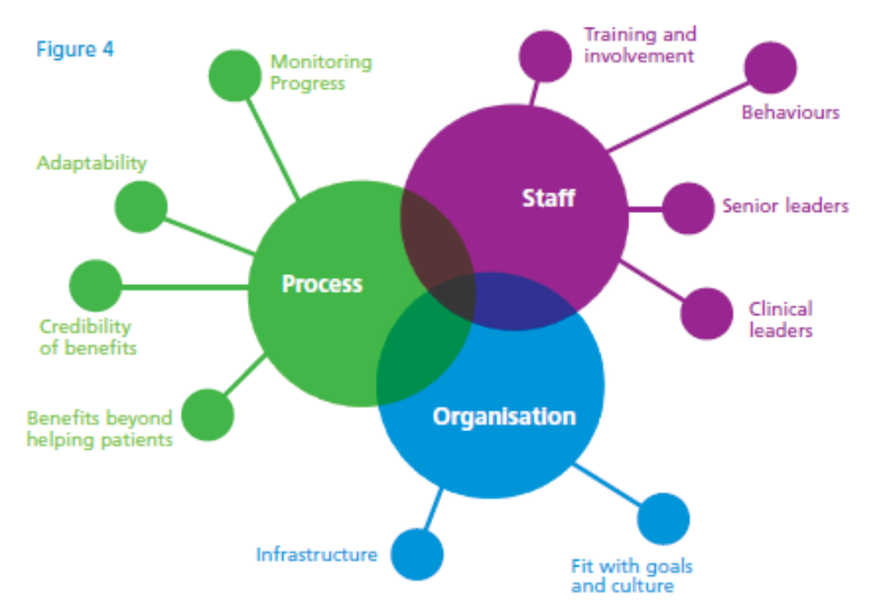

As a starting point, your organisation should assess its current role as a health promoting organisation and its aims for the future. The NHS Sustainability Model provides an approach for addressing any gaps in the current and future position through assessing ten key factors.
The factors included within the tailored model are covered in more detail in the assessment tool on the following pages and you can rate A – D where you think your organisation is currently performing against that factor. You may also want to consider updating the types of indicators you are using to determine your rating to ensure they are meaningful and relevant. You should consider whether or not you want to complete the assessment tool in the context of the whole organisations or teams and departments you plan to start working with (or both). Once you have completed the assessment tool each area and factor can be scored on page 9 to help you assess areas of strength and weakness.
Full details of the NHS Sustainability Model and scoring systems shown can be found at: http://www.institute.nhs.uk/sustainability_model/general/welcome_to_sustainability.html
Assessment Tool
Factor | Examples of indicators | Identify (✓) |  | Factor Level
Benefits beyond helping patients  In addition to helping service users, are there other benefits?  For example:  - Improved staff health and wellbeing  - Enhanced staff skills, confidence and motivation  - Appropriate increased and uptake of lifestyle services  - Cost savings to the organisation  - Will there be additional benefits to services? | Organisations may measure the impact of benefits beyond helping patients using the following:  - changes in sickness absence  - staff feedback  - monitoring outcomes of interaction with patient i.e. signposting and information giving activity  - cost/resource savings to service delivery if patients are improving their health and wellbeing and knowledge of self-care. | A |  | We can demonstrate that an initiative designed to maximise opportunities to promote health and wellbeing has a wide range of benefits beyond helping service users.
 |  | B |  | We can demonstrate that an initiative designed to maximise opportunities to promote health and wellbeing has some benefits beyond helping service users, but not a wide range.
 |  | C |  | We can demonstrate that an initiative designed to maximise opportunities to promote health and wellbeing has one or two benefits beyond helping service users.
 |  | D |  | The benefits of an initiative designed to maximise opportunities to promote health and wellbeing are only directly related to helping service users. We have not identified any other benefits that maximising opportunities to promote health and wellbeing could bring.
Credibility of the benefits  - Are benefits to patients, staff and the organisation visible?  - Do staff believe in the benefits?  - Can all staff clearly describe a full range of benefits?  - Is there evidence that this type of initiative is influential elsewhere? | To ensure benefits are visible they should be discussed during training sessions and revisited as part of team meetings, integral to induction etc  Staff should be given the opportunity to feedback the benefits they see are happening  Mechanisms to capture patient outcomes should be put in place where possible.  Links to NICE Guidance and Healthy Lives, Healthy People | A |  | Benefits of maximising opportunities to promote health and wellbeing are widely communicated, immediately obvious, supported by evidence and believed by stakeholders. Staff are able to fully describe a wide range of intended benefits for this initiative.
 |  | B |  | Benefits of maximising opportunities to promote health and wellbeing are not widely communicated or immediately obvious even though they are supported by evidence and believed by stakeholders.
 |  | C |  | Benefits of maximising opportunities to promote health and wellbeing are not widely communicated or immediately obvious even though they are supported by evidence. They are not widely believed by stakeholders.
 |  | D |  | Benefits of maximising opportunities to promote health and wellbeing are not widely communicated, they are not immediately obvious, nor are they supported by evidence or believed by stakeholders.

Adaptability of improved process  - Can opportunities to promote health and wellbeing overcome internal pressures, or will this disrupt the initiative?  - Do opportunities to promote health and wellbeing continue to meet ongoing needs effectively?  - Do opportunities to promote health and wellbeing rely on a specific individual or group of people, technology, finance, etc, to keep it going?  - Can it keep going when these are removed? | Initiative needs to be integral to the organisational vision and beliefs and job descriptions  Incorporation into induction for continuity as trained staff leave  Use of organisational surroundings and staff intranet to continue to convey health promoting messages  Using the above should support embedding the initiative, thus relying less on individual champions etc  Approach should be person-centred to adapt to the patient and promote empowerment  Top-up training for staff as appropriate. | A |  | The process of maximising opportunities to promote health and wellbeing can link in with, be adapted and even support other organisational changes. It would not be disrupted if specific individuals or groups left the project. Its focus will continue to meet the improvement needs of our organisation
 |  | B |  | The process of maximising opportunities to promote health and wellbeing can be adapted and support wider organisational change but it would be disrupted if specific individuals or groups left the project. Elements of this work will continue to meet our organisation’s improvement needs.
 |  | C |  | It would be difficult for the process of maximising opportunities to promote health and wellbeing to adapt or support other organisational changes. It would cause disruption if specific individuals or groups left the project.
 |  | D |  | The process of maximising opportunities to promote health and wellbeing could not adapt or support any other organisational change happening and it would be disrupted if specific individuals or groups left.
Effectiveness of the system to monitor progress  - Does the initiative require special monitoring systems to identify and continually measure improvement?  - Is there a feedback system to reinforce benefits and progress and initiate new or further action?  - Are mechanisms in place to continue to monitor progress beyond the formal life of the initiative?  - Are the results of the project communicated to patients, staff, the organisation and the wider community? | Activity and outcome monitoring forms  Feedback on uptake of referrals  Changes in patient’s health and wellbeing noted and recorded  All the above integrated into team systems and processes and taught at induction  Communication strategy of results within teams meetings, newsletters etc to other organisations. | A |  | There is a system in place to provide evidence of impact, including benefits analysis, monitor progress and communicate the results. This is set up to continue beyond the formal life of the project.
 |  | B |  | There is a system in place to provide evidence of impact, including benefits analysis, monitor progress and communicate the results. This is not set up to continue beyond the formal life of the project.
 |  | C |  | There is a system in place to provide evidence of impact and monitor progress. However none of this information is communicated more widely than the core project team. The measurement system is not set up to continue beyond the formal life of the project.
 |  | D |  | There is only a very patchy system to monitor progress and this will end at the same time as the project. There is no system to communicate the results.

Staff involvement and training to sustain  the process  - Do staff play a part in innovation, design and implementation of the initiative?  - Have they used their ideas to inform the process from the beginning?  - Is there a training and development infrastructure to identify gaps in skills and knowledge and are staff educated and trained to take the initiative forward? |  | Teams and individuals within the organisation should be involved in designing the process by:  - seeking representation from teams to work with senior management  - seams being allowed flexibility to incorporate relevant processes i.e. redesigning forms and choosing materials to display  Tips on assessing competence – staff TNA. Example training programme. |  | A |  |  | Staff have been involved from the beginning of the process. They have helped to identify any skill gaps and have been able to access training and development so that they are confident and competent in the new way of working.
 |  |  |  | B |  |  | Staff have been involved from the beginning of the process and have helped to identify skills gaps but they have not had training or development in the new way of working.
 |  |  |  | C |  |  | Staff have not been involved from the beginning of the process but they have received training in the new way of working.
 |  |  |  | D |  |  | Staff have not been involved from the beginning of the process and have not had training or development in the new way of working.
Staff behaviours toward sustaining the change  - Are staff encouraged and able to express their ideas regularly throughout the initiative process and is their input taken on board?  - Do staff think that the initiative is a better way of doing things that they want to preserve for the future?  - Are staff trained and empowered to promote health and wellbeing based on their ideas, to see if additional improvements should be recommended? |  | Teams and individuals within the organisation should be involved in designing the process. This can be achieved by:  - staff questionnaires  - use of suggestion boxes  - tailored and flexible training |  | A |  |  | Staff are able to share their ideas regularly and some of them have been taken on board during the process. They believe that maximising opportunities to promote health and wellbeing are important and have been empowered to undertake, as part of their existing roles, the promotion of health and wellbeing to service users.
 |  |  |  | B |  |  | Staff are able to share their ideas regularly and some of them have been taken on board during the initiative. They believe that maximising opportunities to promote health and wellbeing is important. Staff do not feel empowered to run small scale test cycles (Plan, Do, Study, Act).
 |  |  |  | C |  |  | Staff are able to share their ideas regularly but none seem to have been taken on board during the initiative. They don’t think that maximising opportunities to promote health and wellbeing is important. They don’t feel empowered to run small scale test cycles (Plan, Do, Study, Act).
 |  |  |  | D |  |  | Staff do not feel they have been able to share their ideas. They do not believe maximising opportunities to promote health and wellbeing is important and they have not been empowered to run small scale test cycles (Plan, Do, Study, Act).
Senior leadership engagement and support  - Are the senior leaders trusted, influential, respected and believable?  - Are they involved in the initiative, do they understand it and do they promote it?  - Are they respected by their peers and can they influence others to get on board?  - Are they taking personal responsibility to help break down barriers and are they giving time to help ensure the change is successful? |  | Are senior leaders engaged with or aware of the concept and all other elements of this checklist?  Has the case been made to them – example case, why become a health promoting organisation? |  | A |  |  | Organisational leaders are highly involved and visible in their support of an initiative to maximise opportunities to promote health and wellbeing. They use their influence to communicate the impact of the work and to break down any barriers. Staff regularly share information with and actively seek advice from leaders.
 |  |  |  | B |  |  | Organisational leaders are highly involved and visible in their support of an initiative to maximise opportunities to promote health and wellbeing. They use their influence to communicate the impact of the work and to break down any barriers. Staff typically don’t share information with, or seek advice from leaders.
 |  |  |  | C |  |  | Organisational leaders are somewhat involved but not highly visible in their support of an initiative to maximise opportunities to promote health and wellbeing. They use their influence to communicate the impact of the work but cannot be relied upon to break down any barriers if things get difficult. Staff typically don’t share information with, or seek advice from leaders.
 |  |  |  | D |  |  | Organisational leaders are not involved or visible in their support of an initiative to maximise opportunities to promote health and wellbeing. They have not used their influence to communicate the impact of the work or to break down any barriers. Staff typically don’t share information with or seek advice from leaders.
Leadership engagement and support  - Are the leaders trusted, influential, respected and believable?  - Are they involved in the initiative, do they understand it and do they promote it?  - Are they respected by their peers and can they influence others to get on board?  - Are they taking personal responsibility to help break down barriers and are they giving time to help ensure the change is successful? |  | As above |  | A |  |  | Team leaders are highly involved and visible in their support of an initiative to maximise opportunities to promote health and wellbeing. They use their influence to communicate the impact of the work and to break down any barriers. Staff regularly share information with and actively seek advice from leaders.
 |  |  |  | B |  |  | Team leaders are highly involved and visible in their support of an initiative to maximise opportunities to promote health and wellbeing. They use their influence to communicate the impact of the work and to break down any barriers. Staff typically don’t share information with, or seek advice from leaders.
 |  |  |  | C |  |  | Team leaders are somewhat involved but not highly visible in their support for an initiative to maximise opportunities to promote health and wellbeing. They use their influence to communicate the impact of the work but cannot be relied upon to break down any barriers if things get difficult. Staff typically don’t share information with, or seek advice from leaders.
 |  |  |  | D |  |  | Team leaders are not involved or visible in their support of an initiative to maximise opportunities to promote health and wellbeing. They have not used their influence to communicate the impact of the work or to break down any barriers. Staff typically don’t share information with, or seek advice from leaders.
Fit with the organisation’s strategic aims  and culture  - Are the goals of the initiative clear and shared?  - Are they clearly contributing to the overall organisational strategic aims?  - Is improvement important to the organisation and its leadership?  - Has the organisation successfully sustained improvement in the past? |  | Example generic organisational goals  Tools on reviewing progress i.e. utilising and continuing to use this Implementation Guide and Toolkit and Organisational Assessment Tool. |  | A |  |  | The goals of the initiative are clear and have been shared widely. They are consistent with and support the organisation’s strategic aims for improvement. The organisation has demonstrated successful sustainability of improvements before and has a ‘can do’ culture.
 |  |  |  | B |  |  | The goals of the initiative are clear and have been shared widely. They are consistent with and support the organisation’s strategic aims for improvement. The organisation has not demonstrated success in sustaining previous improvements and does not have a ‘can do’ culture.
 |  |  |  | C |  |  | The goals of the initiative are clear and have been shared widely. They have not been linked with the organisation’s strategy so we don’t know if they support any organisational aims for improvement. The organisation has not demonstrated success in sustaining previous improvements and does not have a ‘can do’ culture.
 |  |  |  | D |  |  | The goals of the initiative are not really clear and have not been shared widely. They have not been linked with the organisation’s strategy so we don’t know if they support any organisational aims for improvement. The organisation has not demonstrated success in sustaining previous improvements and does not have a ‘can do’ culture.
Infrastructure  - Are staff fully trained and competent in the new way of working?  - Are there enough facilities and equipment to support the new process?  - Are new requirements built into job descriptions?  - Are there policies and procedures supporting the new way of working?  - Is there a communication system in place? | Attrition rates, induction checklists  Staff questionnaires to seek feedback  Example sentences for JDs and Person Specifications  Draft example for terminology for generic organisational policies i.e. PDPs  Draft example materials for promoting health and wellbeing and supporting staff in making contacts count. |  | A |  |  |  | Staff are confident and trained in the new way of working. Job descriptions, policies and procedures reflect the new process and communication systems are in place. Facilities and equipment are all appropriate to sustain the new process.
 |  |  | B |  |  |  | Staff are confident and trained in the new way of working. However, job descriptions, policies and procedures do not reflect the new process. Some communication systems are in place. Facilities and equipment are all appropriate to sustain the new process.
 |  |  | C |  |  |  | Staff are confident and trained in the new way of working. However, job descriptions, policies and procedures do not reflect the new process and there are no communication systems to adequately support the new process. Facilities and equipment are not appropriate to sustain the new process.
 |  |  | D |  |  |  | Staff have not been trained in the new process and are not confident in the new way of working. Job descriptions, policies and procedures do not reflect the new process and there are no communication systems to adequately support the new process. Facilities and equipment are not appropriate to sustain the new process.

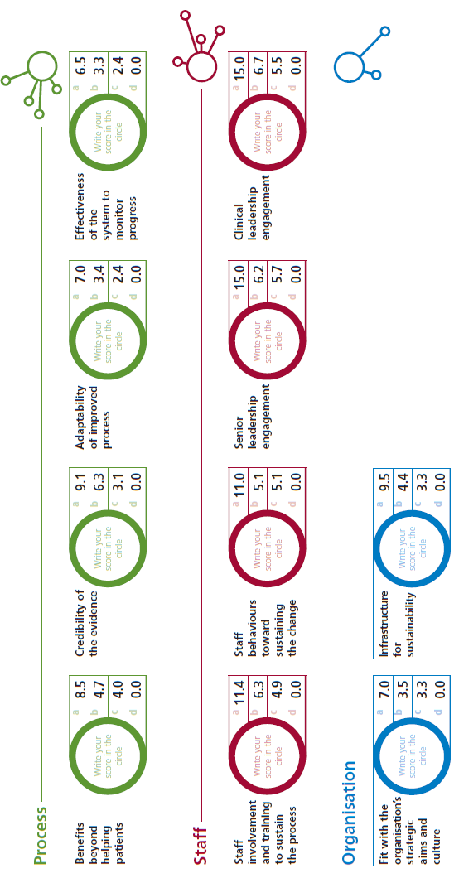
The master scoring system is as follows:
After scoring each factor, the scores should be calculated to provide a total sustainability score:


The next step is to map scores of each factor against the maximum score that can be achieved:
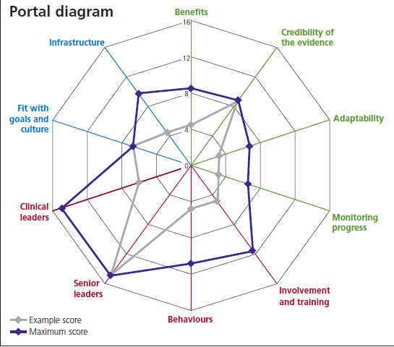

This process will highlight areas of particular focus for ensuring effective and sustainable change needed to support any enhancements your organisation may require.

